- In your account select „My Appliances
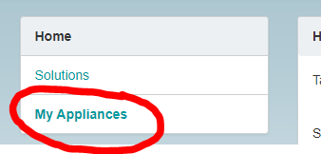
- Select the appliance you want to edit
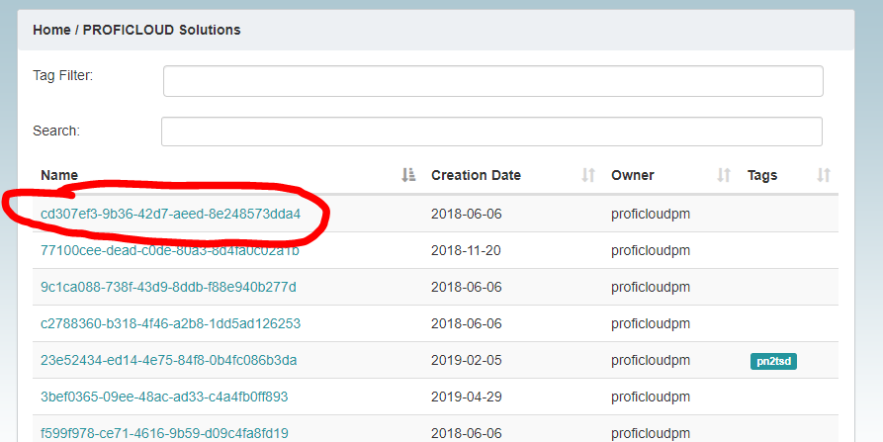

- Release the ownership oft he selected appliance
